Supply Chain Management Using Blockchain

**Mr. M. V. V. Rama Rao**  
*Department of C.S.E.*

*Shri Vishnu Engineering College for Women*

Bhimavaram, India  
 ramaraocse@svecw.edu.in

**Sanjana Pothula**  
*Department of C.S.E.  
Shri Vishnu Engineering College for Women*Bhimavaram, India  
sanjanapothula11@gmail.com

**Sanjana Rachumallu***Department of C.S.E.*

*Shri Vishnu Engineering College for Women*

Bhimavaram, India  
sanjurac07@gmail.com

**Jahnavi Urugonda**  
*Department of C.S.E.*

*Shri Vishnu Engineering College for Women*

Bhimavaram, India

jahnavi22031@gmail.com

**Sylvia Anand Veernapu**  
*Department of C.S.E.*

*Shri Vishnu Engineering College for Women*

Bhimavaram, India  
sylvia512anand@gmail.com

**Yeleti Mahalakshmi**   
*Department of C.S.E.  
Shri Vishnu Engineering College for Women*Bhimavaram, India  
yeletimahalakshmi@gmail.com

***Abstract*** -**The traditional supply chain management is a complex process that is done manually with insufficient data and without any security in transactions. It includes more time and ineffective processes which may cause customers trouble using this application. To store the details of the transactions and history of the products it will be difficult to enter the data manually and to maintain the records for years is arduous. So, if we include blockchain in this traditional supply chain management then we can increase the efficiency and security of the process. The security in the transactions will be in addition. If we use other technology rather than blockchain, we may get laborious when hacking is involved, because it will be hard to find the hacker. But, with blockchain technology, as security is more, the hacker cannot able to access the data and no person outside of the organization can modify or insert the data. Digitalizing physical assets and creating a decentralized, unchangeable record of all transactions are two ways that blockchain can help supply organizations manage assets more accurately and transparently from manufacturing to delivery or end user use. We mainly focus on customers and sellers where the product details will be displayed i.e. when it is manufactured. Because of the details only the security and quality of the product will be known.**

**Keywords** - **Blockchain, Supply chain management, Ganache, Metamask, Solidity, Ethereum.**

# I**ntroduction**

Supply chain management is the movement of goods or products between manufacturers and customers. This flow will follow the process from the core development to the overall development of the product or good. It also includes transporting the product or goods between sources like suppliers, manufacturers, distributors, retailers, customers, etc [1]. As the strategic framework that coordinates the smooth movement of commodities, information, and funds among a network of interrelated entities, supply chain management (SCM) is essential to the modern corporate environment. In today's globalized and highly competitive markets, organizations recognize the critical importance of SCM in enhancing operational resilience, minimizing costs, and optimizing overall performance.

This study explores the fundamental ideas, new developments, and the revolutionary potential of digital technologies as it digs into the complex dynamics of supply chain management. Through examining the opportunities and problems associated with supply chain management, this research seeks to provide industry and academics with insightful knowledge that will deepen our comprehension of the always-changing nature of supply chain operations.

A number of connected processes make up the supply chain management process, which makes it easier for products and services to be moved from suppliers to consumers. The procedure entails:

Identify and choose reliable suppliers based on factors such as quality, cost, and reliability. Establish and maintain strong relationships with suppliers to ensure a smooth flow of materials and information. Negotiate contracts, terms, and conditions with suppliers. Place orders for raw materials or finished goods based on demand forecasts and inventory levels. Convert raw materials into finished goods through manufacturing processes. Optimize production efficiency and quality control measures. Monitor and manage inventory levels to avoid stockouts or excess inventory [1].

Implement just-in-time (JIT) or other inventory optimization strategies. Plan and execute the transportation of goods from manufacturing facilities to distribution centers. Optimize transportation routes and modes to reduce costs and enhance efficiency. Store and manage inventory in warehouses or distribution centers. Implement efficient warehouse layouts and technology for order fulfillment. Receive and process customer orders [6].

Communicate order details to the relevant departments for fulfillment. Coordinate the movement of goods from distribution centers to retailers or end customers.

Utilize various transportation modes, including trucks, ships, planes, etc. Manage inventory at retail locations. Ensure that products are appropriately displayed and available for customers. Pick, pack, and ship products to fulfill customer orders [1].

Provide tracking information and manage returns if necessary. Address customer inquiries, complaints, or issues promptly. Gather feedback to improve processes and enhance customer satisfaction. Handle product returns and manage the reverse flow of goods. Evaluate returned products for possible refurbishment or recycling.

Utilize technologies such as RFID, barcoding, and advanced software systems for real-time tracking and visibility. Implement data analytics for demand forecasting and continuous process improvement. Regularly assess and refine supply chain processes. Adapt to market changes and incorporate new technologies or strategies for increased efficiency.

Fig. 1. Working of Ethereum 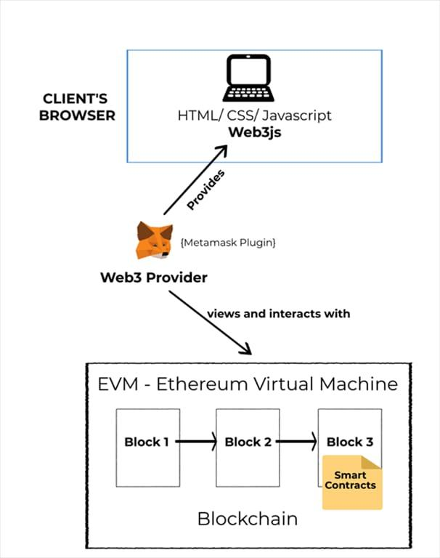

Blockchain's decentralized control is a paradigm shift from traditional supply chain models. Control is shared among all network members rather than depending on a single entity. This decentralization eliminates single points of failure, enhances resilience, and ensures that the supply chain remains operational even in the face of disruptions.

Improved traceability is another significant advantage of implementing blockchain in supply chain management. A unique identifier that is recorded on the blockchain can be issued to each product or batch, allowing precise tracing of its path from the point of origin to the point of destination. This traceability is invaluable in identifying the source of issues such as recalls or counterfeit products, allowing for swift corrective actions.

Increasing efficiency is a natural outcome of adopting blockchain in supply chain processes. The streamlined and automated execution of smart contracts within the blockchain network reduces the need for intermediaries, minimizes paperwork, and accelerates transaction times. This efficiency translates to cost savings and quicker response to market demands.

One significant financial benefit of using blockchain technology in supply chain management is reduced expenses. Blockchain helps to save costs at every stage of the supply chain lifecycle by eliminating the need for middlemen, lowering errors, and improving overall efficiency [1].

# RESEARCH PROBLEM AND OBJECTIVES

* The integration of blockchain technology into conventional supply chain management is being done to increase security and efficiency.
* By ensuring immutable transactions and offering security, blockchain enhances transaction transparency.
* Our research is creating a blockchain website that incorporates Ethereum technology. With the help of the Ethereum network protocol, users may design and execute smart contracts across a decentralized network.
* Ethereum does away with the requirement for a middleman to manage peer-to-peer transactions.

Objectives:

1. **Enhanced Transparency**:

Every member of the network has access to the blockchain and can confirm the transactions listed there. As a result of their ability to independently verify and assure the accuracy of the data, participants' trust is increased by this transparency.

1. **Smart contracts**:

Due to their ability to do away with middlemen and provide transparency in contract execution, smart contracts improve confidence in data transactions.

1. **Decentralisation:**

A centralized authority is not necessary with blockchain. As there is no longer a reliance on a single point of control and there is less chance of data modification or unauthorized access, this decentralized structure increases confidence.

1. **Immutability**:

Blockchain's inherent nature as a distributed ledger makes it difficult to remove or modify data once it is recorded.

1. RELATED WORKS

An essential part of contemporary corporate operations is supply chain management (SCM), which covers the entire process of organizing, sourcing, producing, shipping, and receiving returns for goods. SCM has drawbacks even if it plays a crucial part in guaranteeing the successful and efficient flow of products.

One significant challenge lies in the complexity of global supply chains. As companies expand their operations globally, the interconnectedness of suppliers, manufacturers, and distributors increases, leading to heightened vulnerability. Disruptions, such as natural disasters, geopolitical events, or pandemics, can ripple through the supply chain, causing delays, shortages, and increased costs.

In SCM, accurate and timely information is crucial for decision-making. However, miscommunication, inaccurate data, or delays in information flow can result in suboptimal choices. This lack of transparency may lead to excess inventory, stockouts, or inefficiencies in production.

When it comes to solving many of the problems in the field of supply chain management (SCM), blockchain technology has proven to be a revolutionary force. With its innovative approach to improving traceability, transparency, and security throughout the supply chain, this decentralized and transparent ledger system promotes efficiency and confidence among stakeholders.

The absence of transparency in traditional supply chains is one of the main problems. There may be complicated information flow between the different supply chain participants, which can cause mistakes, delays, and inefficiencies. Blockchain addresses this issue by giving all authorized participants access to a single, unchangeable ledger. All events and transactions in the supply chain, from production to delivery, are publicly and safely documented. By guaranteeing that all parties involved have instant access to a single version of the truth, this lowers the possibility of inconsistencies and raises transparency levels all around.

Traceability is another problem that blockchain technology attempts to solve in supply chain management. Tracking the origin and path of products in traditional supply chains can be difficult and time-consuming. In businesses like food and pharmaceuticals, where product authenticity and quality are critical, this becomes especially important. End-to-end traceability is made possible by blockchain's capacity to produce an irreversible record of each transaction. Every stage, from the procurement of raw materials to the delivery of the finished product, is tracked on the blockchain, allowing for the prompt detection of problems like contamination or counterfeiting as well as the facilitation of targeted recalls.

Smart contracts, a feature of blockchain technology, further contribute to the efficiency of supply chain processes. These self-executing contracts automatically enforce and execute predefined rules when specific conditions are met. Smart contracts have the potential to alleviate the need for middlemen and minimize delays in supply chain management procedures like payment settlements. The likelihood of mistakes and disagreements is decreased in addition to increasing efficiency through automation.

Additionally, blockchain addresses the challenge of information security in supply chains. The blockchain's data storage system guarantees security and resistance to tampering due to its decentralized and encrypted nature. When handling private information like product specs, costs, and contract terms, this is especially important. The immutability of blockchain records instills confidence among stakeholders, fostering a more secure and trustworthy supply chain environment.

# LITERATURE REVIEW

1. Traditional Supply Chain Management System:

Disruptions to the supply chain clearly have an economic impact, and the pandemic's natural basis emphasizes how important environmental sustainability is [7]. Focusing on recent advancements and emerging trends of Supply chain management using Block chain, by providing an overview of challenges in Traditional Supply chain Management like scalability and data privacy along with benefits such as traceability and transparency [5].

1. Challenges and Benefits in Supply Chain Management System:

Understanding of Supply chain management System by facilitating the interrelationships between different elements and stages in Supply chain [2]. A supply chain's ability to endure and sustain itself in a changing environment was demonstrated by the Viable Supply Chain (VSC) model. The four main viewpoints on viability are sustainability, resilience, agility and digital technologies [8].

1. Understanding of Block chain Technology:

This article focuses on the critical function that blockchain technology plays and how it has sparked a conversation in the innovation and technology community. In addition to exploring blockchain technology's potential applications in supply chain management, this article offers the first overview of the technology [3].

1. Applications of Supply chain Management System:

This survey analyzes the use of blockchain technology in supply chain management with a very broad focus on industrial applications, managerial consequences, and societal impact [4].

1. Optimization and Integration of the Supply chain:

The paper aims to the opportunities offered by blockchain in optimizing supply chain processes an trust and transparency among stakeholders [11]. The paper also identifies key research opportunities for further investigating the integration of blockchain into supply chain operations, offering insights into future developments and challenges in this rapidly evolving field [12].

The global economy depends heavily on supply chain management (SCM), which makes it easier for products and services to get from producers to final customers. The application of blockchain technology to supply chain management (SCM) has drawn more interest in the past few years. Blockchain can completely transform current supply chain procedures because it is a distributed ledger that is tamper-resistant and decentralized.

Due to its decentralized structure, blockchain guarantees traceability, security, and transparency. Every transaction and data entry is kept track of in a block, which is connected to other blocks in a chain. Traditional supply chains encounter several issues, including inefficiency, fraud, and lack of visibility. These issues may be resolved by this transparent and unchangeable ledger system.

An important benefit of incorporating blockchain technology into supply chain management is the enhancement of transparency and traceability. Blockchain technology makes it possible to track and log every transaction that occurs in the supply chain in real-time, giving all parties involved access to an extensive and unchangeable record. This openness guarantees the validity of the items, reduces the possibility of counterfeit goods, and improves the supply chain's overall visibility.

Supply chain procedures can be automated by using smart contracts, which are self-executing contracts with the conditions of the agreement explicitly encoded into code. Businesses may automate a number of processes, including order fulfillment, compliance checking, and payment processing, by utilizing smart contracts on a blockchain. This increases the effectiveness and velocity of supply chain interactions while also decreasing the need for middlemen.

The use of blockchain technology into supply chain management is not without difficulties, despite its possible advantages. For broad acceptance, problems including scalability, interoperability, and the requirement for established protocols must be resolved. Additionally, concerns related to data privacy, regulatory compliance, and the environmental impact of blockchain technology remain topics of ongoing research and debate.

Future directions are beginning to emerge as supply chain management research on blockchain keeps developing. In order to develop more intelligent and responsive supply chains, researchers are looking into advanced applications of blockchain, such as fusing it with other cutting-edge technologies like the Internet of Things and artificial intelligence. As businesses look for creative ways to streamline their processes in an increasingly complicated global marketplace, cooperation between academia and industry will be essential in determining how blockchain is used in supply chain management in the future.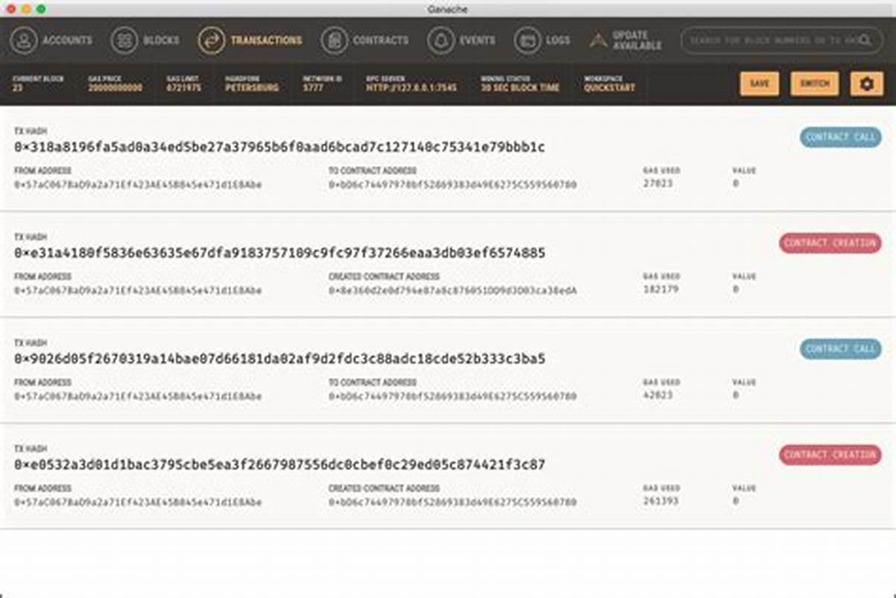

# PROPOSED METHODOLOGY

There are many other processes to achieve supply chain management. The processes with exclude blockchain are not secure and transactions are not safe through those methods. So, we can say that supply chain management with blockchain can be the best process for contracts and transactions with the required benefits needed for the customer. Nowadays, people are showing interest in projects using new technologies. For supply chain management the blockchain process involves many other tools like Ganache, metamask, Visual Studio, etc.

Architecture:

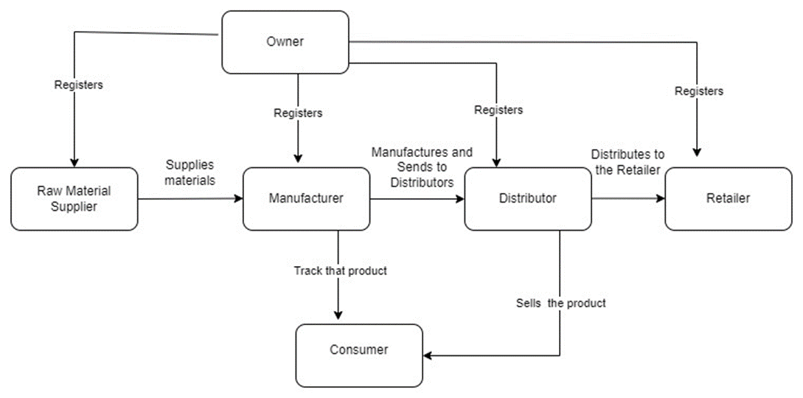

Fig. 2. Architecture diagram

1. Ganache:

Ganache is used for the overall development of the project, it leverages various features and technologies to enhance security and efficiency of the data storage.[9] This tool is used to develop the project by giving different scenarios and testing those scenarios whether they are working fine or not. If those test cases are successfully working then we can deploy them directly into the project. This is the main part of the blockchain project where we can create a strong base for the project with different scenarios and test cases useful for the project. This tool is also used for debugging to check the created test cases, one of the key component of this tool is to implement the advanced encryption algorithms to ensure the confidentiality and integrity of stored data[9]. Our project contains a separate truffle config file, which is mainly used for the ganache.

Fig. 3. Ganache interface

Based on this file, the ganache will provide the addresses and keys for the people who are involved in developing the product or goods. So, this is the main tool for the application.

The developers who are developing the blockchain project should mainly concentrate on the ganache because they are the people who are experimenting with the test cases with different scenarios.

1. Metamask:

An addition to the blockchain wallet that handles contracts and transactions is called MetaMask. MetaMask is essential to the field of supply chain management because it allows users to communicate with blockchain apps, particularly those developed on the Ethereum network.

We have to add the extension of the metamask to Chrome or other search engines. We have to create an Ethereum project in the metamask. The addresses and private keys created in the ganache are added to the metamask to connect the project. Based on the private keys added, the transactions will occur between the different sources. Finally, the products or goods will reach the customer after all these stages. We can also use other tools which work similar to these. These transactions and contracts will be secure and safe as they can only be restricted to the people who are using the project. They cannot be edited and modified. All the transactions are stored in the cloud or database for verification purposes.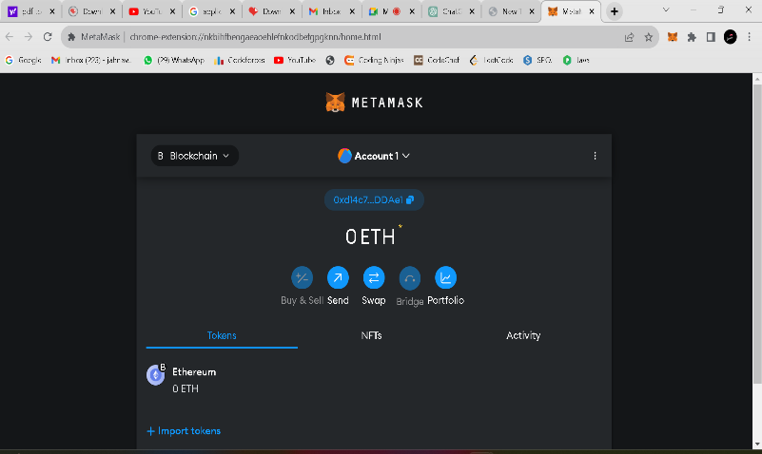

Fig. 4. Metamask interface

Metamask is a popular Etherum wallet that operates as a browser extension , it provides a secure and convenient interface for users to manage their Etherum funds and interact with decentralised applications [10] .Smart contracts built on Ethereum can be easily integrated into supply chain operations thanks to MetaMask. Order fulfillment, record-keeping, and payment settlement are just a few of the supply chain processes that smart contracts may automate. MetaMask acts as a bridge, enabling users to interact with these smart contracts through a user-friendly interface.

This guarantees the transparency and immutability of the recorded data on the Ethereum blockchain in addition to improving supply chain activities' efficiency.

1. Solidity:

Solidity is an object oriented programming language used to write programs such as smart contracts, which can be run by EVM. It is a new programming language that is a combination of the conventions from networking , assembly language and web development [10].Ethereum is one of the most well-known blockchain systems, and Solidity is a high-level programming language made especially for creating smart contracts on these networks. Solidity is essential to supply chain management because it enables smart contracts to automate and carry out business logic. Smart contracts facilitate transparency, immutability, and trust among supply chain participants by enacting terms directly into code and functioning as self-executing agreements.

The development of smart contracts that correspond to different supply chain phases is one method Solidity is applied to supply chain management. One way to use smart contracts is to configure them to run automatically in response to specific events, as when a product is sent, received, or goes through quality control inspections. Because of this automation, there is a decreased need for middlemen, a lower chance of mistakes, and a more secure blockchain record of supply chain activities.

Furthermore, Solidity makes it possible to integrate supply chain elements like transparency and traceability. The blockchain allows for the transparent and unchangeable recording of every event and transaction in the supply chain, making it available to all authorized parties. By improving accountability and lowering the likelihood of fraud or counterfeiting, this transparency aids in tracking the origin, transportation, and status of products. Overall, Solidity's capability to create robust, decentralized, and automated smart contracts makes it a powerful tool for improving efficiency and accountability in supply chain management on blockchain platforms.

This SCM with blockchain can be used by any sector like agriculture, industries, railways, factories, etc. For every sector where the products or goods are developing and selling to the customers, we can use this supply chain process project.

# Results and Discussion

Here, the result will be the track of the product. Like, as in which stage the product is currently and the details of the supplier, manufacturer, distributor, and retailer who are developing the project. There are four stages in the project register the product, order the product, control the supply chain of the product, and track the product.

In the first stage, the owner should register raw material suppliers, manufacturers, distributors, and retailers. For register purposes, we use the addresses of the people involved in the ganache. The addresses should be registered in the project. In the second stage, we can order the products by giving the product name and product ID. So that, we can use this id to track the product. The ID should be unique for all the products. In the third stage, we will add the suppliers, manufacturers, distributors, and retailers who are involved in developing the particular product by using their private key addresses. Now in the last stage, by entering the product name or ID, we can get the complete track report of the product and the people involved in it. So it will be easy to find in which stage the product is and from where the product is manufactured. We will get complete details of the product here.

In metamask, by adding the details and addresses of the persons the transactions will be done parallelly without any extra effort. It will perform the transactions between suppliers and manufacturers, manufacturers and distributors, etc. Here the money can be calculated in Ethereum (ETH) or gas.

# Conclusion

The incorporation of blockchain technology into supply chain management (SCM) has resulted in a revolutionary change, enabled by platforms such as Ganache and Metamask. This convergence improves transparency, traceability, and overall efficiency by addressing important industry concerns.

Blockchain, as a decentralized and immutable ledger, ensures a single version of truth across the supply chain. This is especially important in supply chain management (SCM), as there are numerous parties involved, each with their own data and set of procedures. Every link in the supply chain can obtain a transparent and safe transaction record by utilizing blockchain technology. This fosters trust and minimizes the risk of discrepancies or fraudulent activities.

The use of Ganache, a personal blockchain for Ethereum development, provides a practical and controlled environment for testing and simulating blockchain applications. It allows SCM professionals and developers to experiment with various scenarios, ensuring the robustness and reliability of the implemented solutions before they are deployed in a production environment.

A wider spectrum of enterprises can now access blockchain development with Ganache's cost-effective and scalable approach. Because of Ganache's versatility and ease of use, developers can design customized solutions to solve certain supply chain problems. Its characteristics support the creation of safe, open, and effective systems, building stakeholder confidence and setting the stage for an ecosystem of the supply chain that is more responsive and resilient.

Metamask, a cryptocurrency wallet and gateway to blockchain applications adds another layer of usability to the SCM ecosystem. With Metamask, users can seamlessly interact with blockchain-based supply chain applications, making the technology more accessible and user-friendly. For broad adoption by all parties involved in the supply chain—from producers and distributors to retailers and customers—this inclusion is crucial.

By lowering the possibility of fraud, unauthorized access, and data manipulation, this improves the overall security of the supply chain data and transactions. MetaMask simplifies the blockchain's complexity, making it easier for users to interact with it. Non-technical users may interact with smart contracts, track product provenance, and confirm authenticity throughout the supply chain more easily because of its user-friendly interface and straightforward architecture.

The entire supply chain ecosystem is made more transparent, secure, and efficient through the use of Solidity, a programming language created for Ethereum blockchain smart contracts. By utilizing Solidity smart contracts, stakeholders within the supply chain can automate and streamline various processes, including tracking and verifying the authenticity of products, recording transactions, and enforcing contractual agreements.

Supply chain players are more likely to trust one another because of the immutability and decentralized nature of blockchain, which guarantee transparent and tamper-resistant data. 6A groundbreaking approach that solves a number of the problems with conventional supply chain systems is Solidity for Supply Chain Management, which leverages blockchain. An ecosystem for the global supply chain that is

more dependable and trustworthy is made possible by the integration of smart contracts written in Solidity, which increases efficiency, transparency, and security.

In summary, a new era of effectiveness, openness, and confidence in supply chain management is ushered in by the combination of blockchain with Ganache, Metamask, and solidity. By providing a safe and efficient method of handling the intricate network of exchanges and transactions in the supply chain, this technological synergy resolves long-standing problems in the sector. The potential advantages of this technology are enormous for both consumers and businesses, and it will open the door for a more responsive and robust global supply chain ecosystem as it develops and gains traction.

# ReferenceS

[1]Chopra, S., & Meindl, P. (2019). Supply chain management: Strategy, planning, and operation. Pearson.

[2] Seuring, S., & Müller, M. (2008). From a literature review to a conceptual framework for sustainable supply chain management. Journal of Cleaner Production, 16(15), 1699-1710.

[3] Amulya Gurtu: supply chain management with blockchain technology's potential.

[4] Shuchih Ernest Chang's book, When Blockchain Meets Supply Chain: A Systematic Literature Review on Current Development and Possible Applications, was published in 2017.

[5] "Blockchain technology in supply chain management: An application perspective" by Trung Thanh Nguyen, Phuc Doan Nguyen, and Hong Va Le. Published in 2018

[6] Lee, H. L., & Tang, C. S. (2018). Reshaping the future of supply chain management. Journal of Operations Management, 60, 1-10.

[7] Sarkis, J. (2019). Supply chain sustainability: Learning from the past and mapping a path forward. Decision Sciences, 50(2), 231-256.

[8] Ivanov, D. (2020). Viable supply chain model: Integrating agility, resilience, and sustainability perspectives—Lessons from and thinking beyond the COVID-19 pandemic. Annals of Operations Research, 1-21.

[9] Garima Mathur.(2023). GANACHE : A Robust Framework for Efficient and Secure Storage of Data on Private Etherum Blockchains.

[10] Dr. Kumud Saxena , vaibhav kushwaha, Umang Gupta(2023) Etherum transaction using metamask wallet.

[11] Trivedi, A., Patel, V., & Prajapati, B. (2020). Blockchain technology in supply chain management: A review. In 2020 International Conference on Smart Electronics and Communication (ICOSEC) (pp. 548-553). IEEE.

[12] Sarkis, J., & Cohen, M. J. (2019). Blockchain applications and research opportunities in supply chain management. Transportation Research Part E: Logistics and Transportation Review, 125, 423-441.